Object Modeller Installation Notes

Purpose
This document describes the installation routine that must be used to install the demonstration version of the OpenROAD Object Modeler. The routine sets up all the required repository tables and also places any required 3GL routines and 4GL images in the correct places.

System Requirements
In order to run the Object Modeler the following software requirements must be met:

Software:
Windows NT 4.0
CA- OpenROAD 4.0 with Patch 5833
Ingres II

Preparatory Work
Before the Object Modeller can be installed a database must be set up that the modeler will use as a repository to hold details about models under construction. All the repository tables created will be placed in the ii_database database location so it is important that this database location exists. A complete list of the tables created is given in Appendix A of this document.

It is also important that directories are created on the PCs hard drive into which the Object Modeler images and 3GL DLLs etc. can be placed.

Running the Install Routine
Please note that the installation routine must be run by a user who is logged onto the PC as the DBA of the database onto which the modeler repository tables are to be placed.

First unzip the files in the objmdl.zip file to a directory using WinZip 7.0 . Please note that the "use folders" option in WinZip must be ticked when unzipping the files. Before the installation routine is run, use the IngStart utility to start Ingres on the PC. Next press the Start button on the Windows Taskbar and select the Run option and use this to run the instal.bat file which was placed in the directory into which the objmdl.zip file was unzipped to.

The Object Modeller installation routine will now run, displaying a frame that enables details about the Object Modeller installation to be specified.

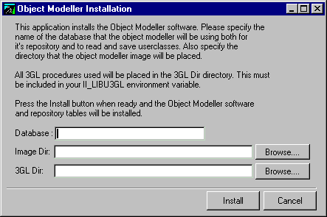
The first field on the screen takes the pathname of the directory in which the objmdl.zip file was extracted to. The browse button beside the field can be used to set the contents of this field.

The name of the database on which the Object Modeler will create it's system tables must be entered in the second entry field.

The next entry field contains the name of the directory, complete with drive letter that is to hold the Object Modeller image file. For example, entering "c:\testinst" would place the images in the c:\testinst directory from where they can be run. Alternatively, the Browse button can be used to select the directory.

Finally, the location in which to place any 3GL files required e.g DLLs, must be entered in the bottom entry field. In order for the 3GL routines to be found correctly when the Object Modeller is executed this path must also be included in the II_LIBU3GL environment variable. Again, the Browse button can be used to select a directory.

Note, both the database and directories specified above must exist before the installation routine is run.

Once all the details have been provided the Install button can be clicked which will install the various tables onto the named database, and will also copy the required Object Modeller files.

The installation routine also places the directory objmodel under the II_SYSTEM\ingres\files directory.

Setting the Environment Variables
Before the Object Modeller can be used, the describ.dll routine that was installed in the directory specified as the 3GL directory must be included in the II_LIBU3GL Ingres environment variable. In addition the Windows user32.dll file must be specified in this line. For example, if the directory c:\testinst was specified as the 3GL directory and Windows is installed in the c:\winnt directory then the II_LIBU3GL variable must contain as a minimum:

II_LIBU3GL = c:\winnt\system32\user32.dll;c:\testinst\describ.dll

Starting the Modeller
Once the Object Modeller has been installed it can be run using the W4GLRUN executable, either by creating a shortcut or by using the RunImage utility. The modeller must be run using the -d flag to specify the database that holds the repository tables.

Appendix A - Tables
The following tables are created by the demo version of the Object Modeler:

Attribute_id_table
Class_id_table
Messagetable
Method_id_table
Model_attributes
Model_classes
Model_comments
Model_header
Model_id_table
Model_methods
Model_notes
Model_relationships
Note_id_table
Relationship_id_table
Simpledatatypestable
Systemclasstable

Appendix B - 3GL Routines
Currently, the only 3GL routines used by the Object Modeller are:

Describ.dll
User32.dll (supplied as part of Windows NT)

This routine must be specified in the II_LIBU3GL Ingres variable.

Appendix C - 4GL Images
The Object Modeller image is called:

Objmdl.img

